14 October 2013

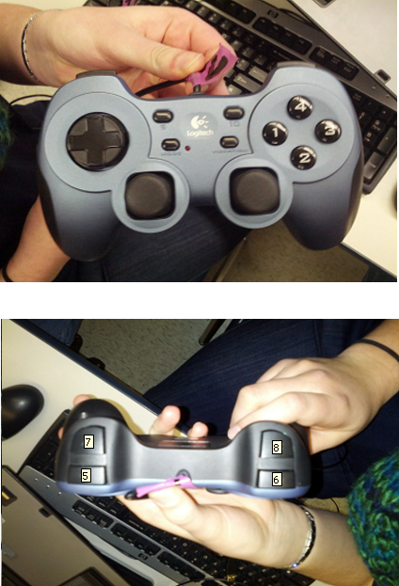**Sally Control Scheme**

**Driver controller (controller #1)**

**Joysticks**

Left—tank drive, left side

Right—tank drive, right side

**Buttons**

1—knee-knocker (toggle)

6—half speed (press-and-hold)

10—raise/lower climber (toggle)

**Shooter controller (controller #2)**

**Joysticks**

Left—target rpm adjustment

**Buttons**

2—quick shoot (press-and-hold)

5—launcher wheel (press-and-hold)

6—fire frisbee (press-and-hold)*

7—lower shooter (press-and-hold)

8—raise shooter (press-and-hold)

*button 5 must be held down for this to have any effect